МИНИСТЕРСТВО НАУКИ И ВЫСШЕГО ОБРАЗОВАНИЯ  
РОССИЙСКОЙ ФЕДЕРАЦИИ

федеральное государственное автономное   
образовательное учреждение высшего образования  
«Самарский национальный исследовательский университет   
имени академика С.П. Королева»

(Самарский университет)

Институт информатики, математики и электроники

Факультет информатики  
Кафедра суперкомпьютеров и общей информатики

**Отчет по лабораторной работе №1**

Дисциплина: «Развертывание и жизненный цикл программного обеспечения»

Тема: **«VM and RAID»**

Выполнил: Доружинский Д.В.

Группа: 6133-010402D

Самара 2022

Steps

1. Create Virtual Machine with Debian/Ubuntu/CentOS or download preinstalled image (https://www.osboxes.org/). VM without GUI. Set virtual machine name with your last name.
2. Add simple RAID1 to Virtual Machine: *nix OS System on 1-st HDD, 2d and 3d HDDs are in RAID1. 2 (with star). only two HDDs. OS System on RAID1, based on this two HDD.
3. How to test RAID1. Create file on RAID1 file system. Turn off VM and remove one of the HHDs from VM. Turn on VM. File should be accessible.
4. Add new HDD and sync it to RAID1.
5. Add section with Assignment1 description into docx and send by e-mail for checking.

PROCEDURE

Install an Ubuntu Server virtual machine using Virtual Box and add two HDDs to the VM:

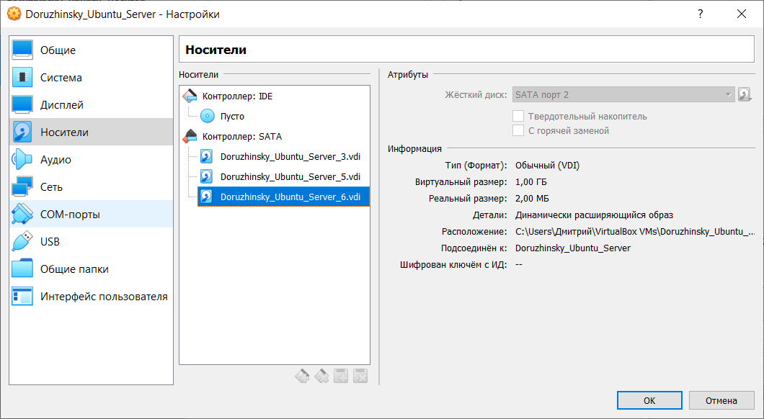

We start Ubuntu Server, and check the display of HDD

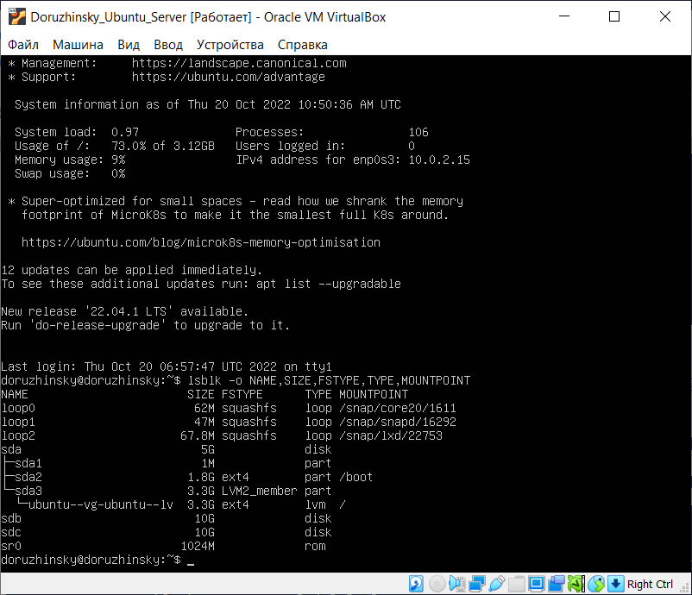

Create RAID1 based on sdb and sdc. In order to do that, create two primary partitions sdb1 and sdc1 respectively with the fdisk utility program:

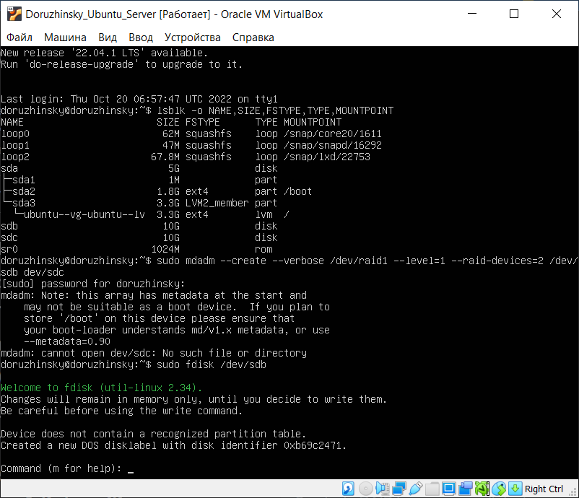

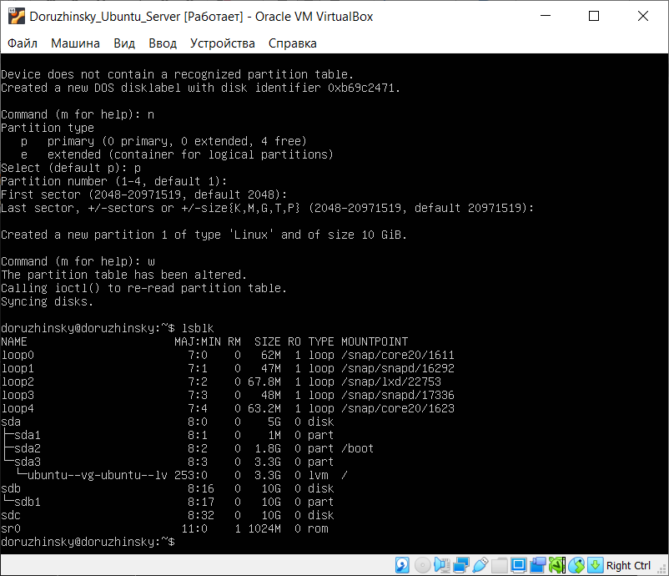

Check for creation success.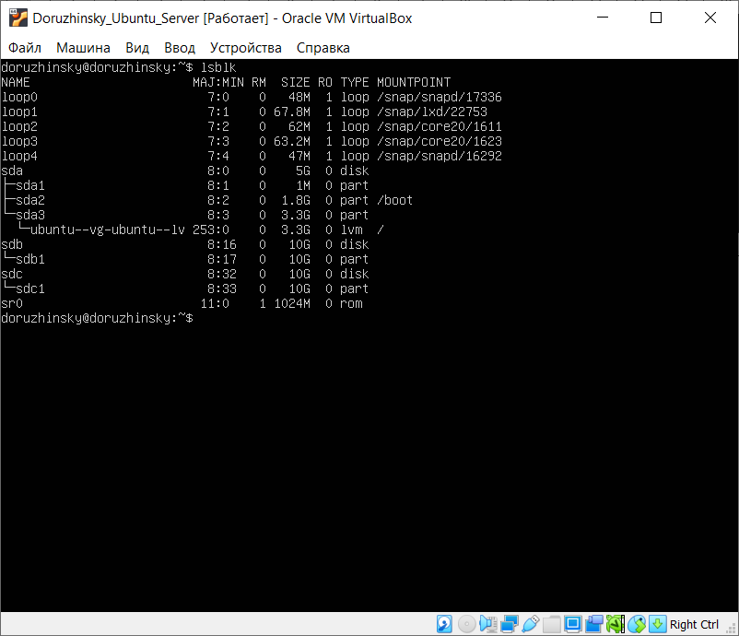

The two partitions created successfully.

Create a RAID1 array in /dev/md0 based on the created partitions using the mdadm command:

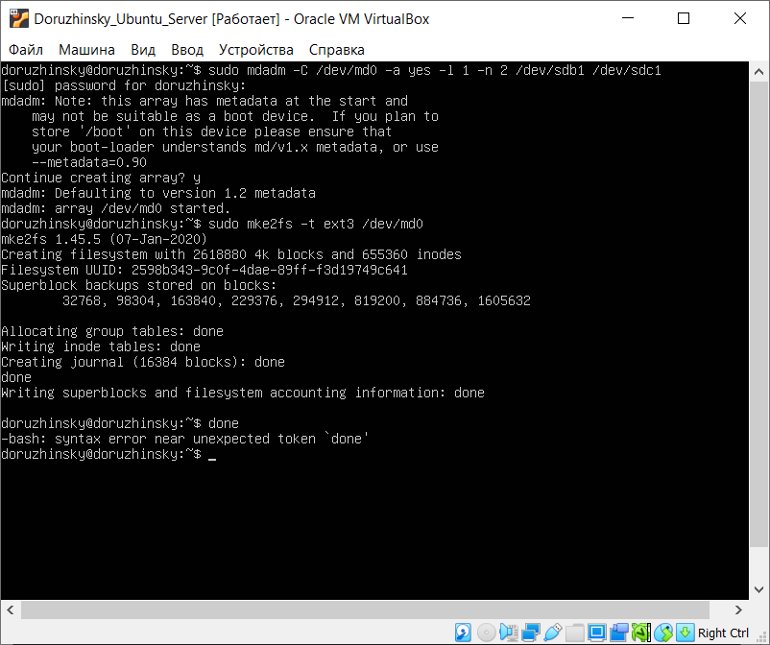

Mount the file system

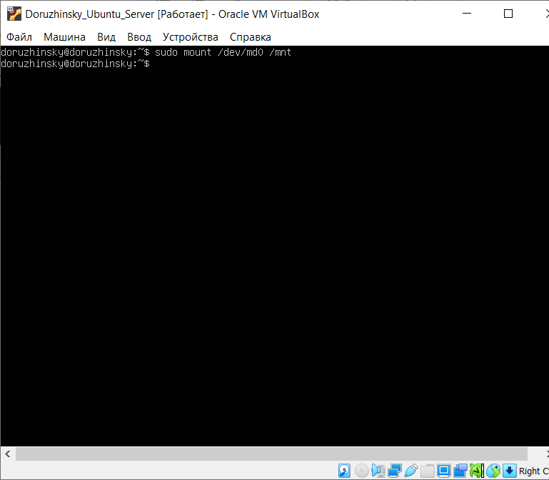

Check for success:

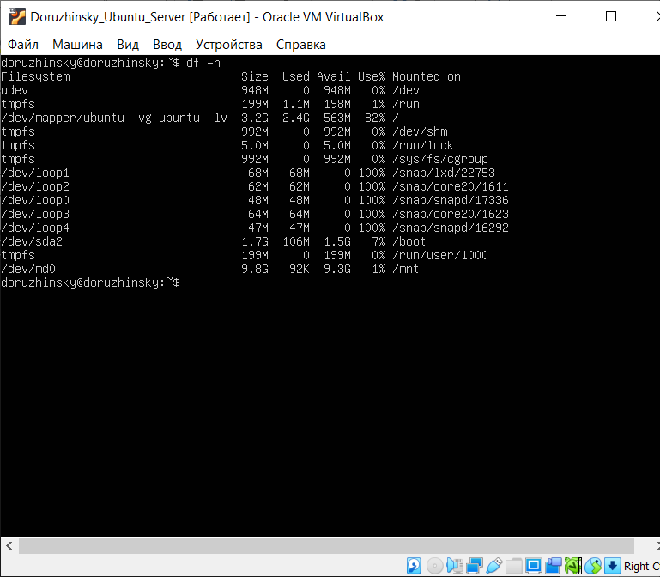

Save the created partitions to mount them automatically each time the system boots. In order to do that, get the UUID of the RAID1 array:

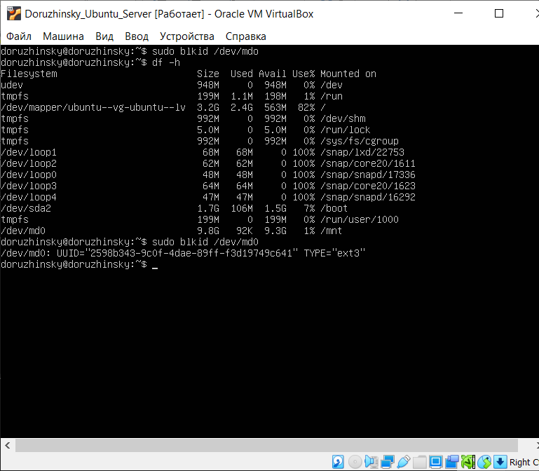

Then edit the /etc/fstab file containing the boot information and paste the UUID in there with corresponding options. Display the edited file:

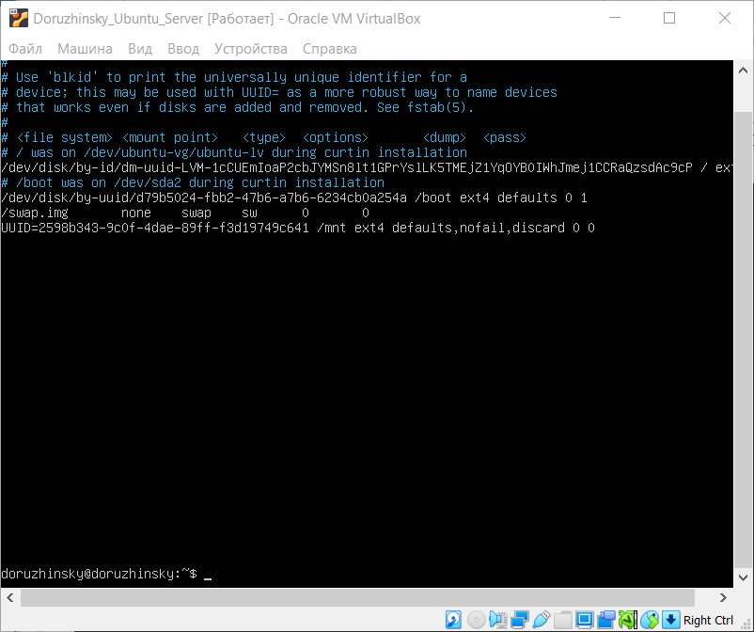

Test RAID1. In order to do that, add a test file in the /mnt directory as shown on the picture below:

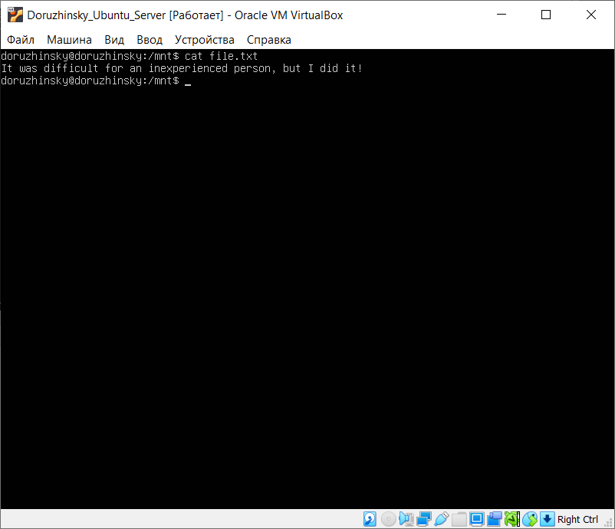

Then remove sdc1 from RAID1 and check if the file is left

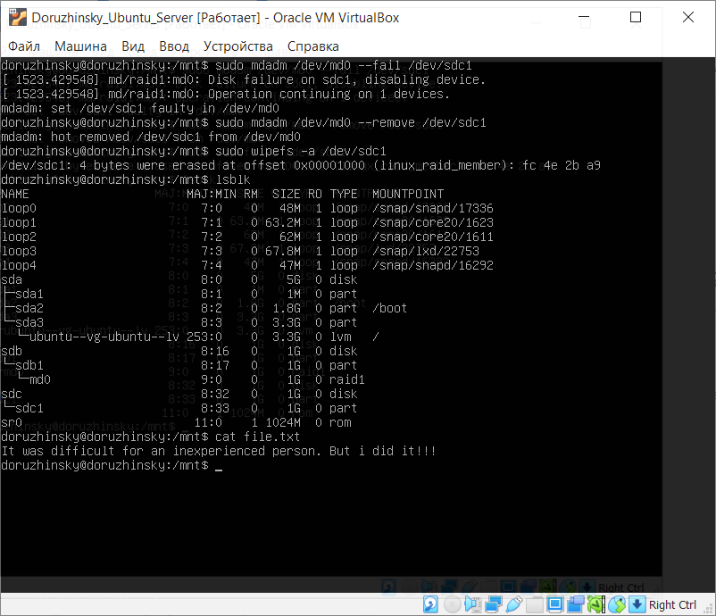

The file left unaffected.

Turn off the VM and remove one of the disks:

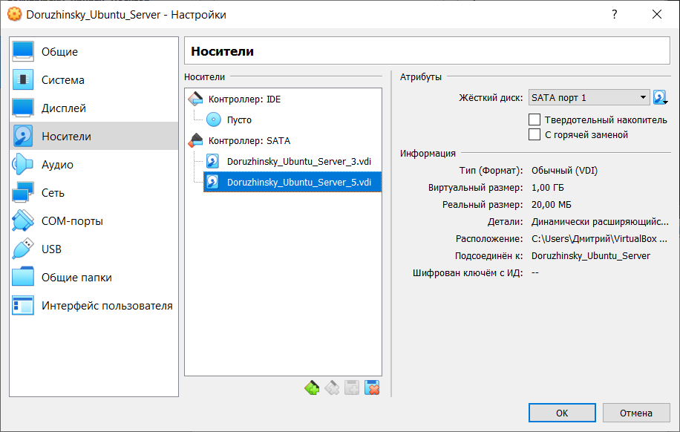

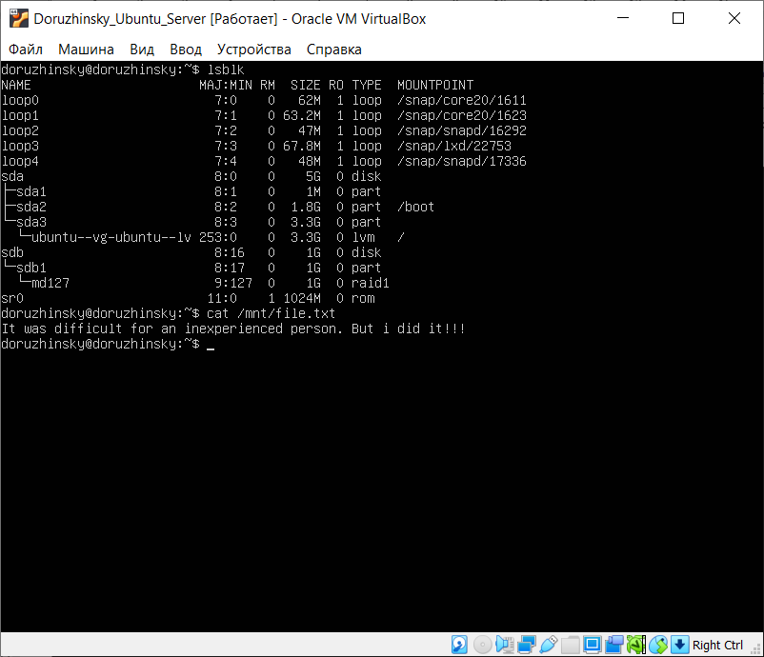

Turn the VM off and add a new HDD to it:

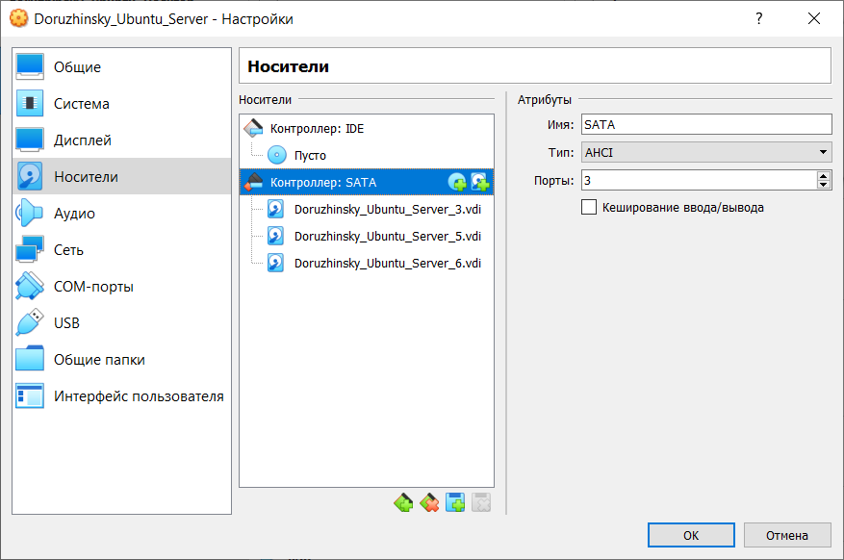

Turn the VM back on and display its disks: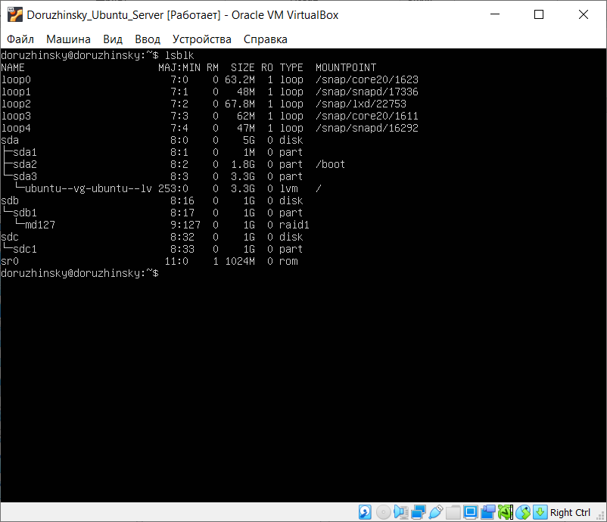

The new HDD detected but not added to RAID. Add it with the following command and check for success:

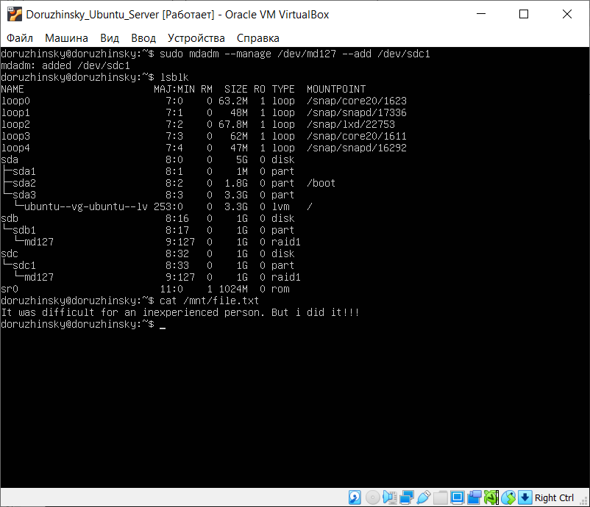

The test file still left unaffected.

**CONCLUSION**

In the conclusion of the laboratory work, the basic utilities of the Ubuntu system studied for working with the file system, partitioning and creating RAID arrays; all steps completed successfully.